 | The CAMECA IMS 7f  Vacuum system user's guide  00 45 633 910 - Type 108 – Indice A
0000.doc

Index

Contents
1. HARWARE CONFIGURATION OF THE VACUUM SYSTEM : 3
1.1. Vacuum circuit: 3
1.1.1. IMS 7f Pumps: 4
1.1.2. IMS 7f Vacuum gauges: 5
1.1.3. IMS 7f Valves: 6
1.2. IMS 7f Automated Vacuum Control Chassis : 7
1.3. IMS 7f Gauge control chassis and pump supplies : 11
1.3.1. TURBOPUMPS CONTROLLERS CHASSIS 11
1.3.2. VACUUM GAUGES CONTROLLERS CHASSIS 11
1.3.3. SPECTROMETER ION PUMPS POWER SUPPLY CHASSIS 11
1.3.4. TITANIUM SUBLIMATION CONTROL UNIT 11
1.4. The IMS 7f BAKING SYSTEM : 11
1.4.1. IMS 7f BAKE-OUT SYSTEM DESCRIPTION 11
1.4.2. GENERAL OPERATION 13
1.4.3. SETTING TO WORK 13
2. SOFTWARE OPERATION – SYNOPTIC IN ‘CONTROL AUTO’ MODE: 14
2.1. VACUUM OPERATIONS : 15
2.1.1. INTERRUPTION OF A VACUUM OPERATION, ERROR MESSAGES: 16
2.1.2. VACUUM SURVEY SYSTEM: 16
2.1.3. POWER FAILURE: 17
2.1.4. PUMP OR VENT OPERATION: 17
2.2. VACUUM PROCEDURES : 17
2.2.1. Pump/Vent Cesium source 17
2.2.2. Pump/Vent Duoplamatron 18
2.2.3. Pump/Vent Airlock: 19
2.2.4. Pump/Vent Analysis Chamber and Primary column 20
2.2.5. Pump/Vent Spectrometer 21
2.2.6. Pump/Vent "General" 23
2.2.7. Pump Gas line 23
2.2.8. Open/Close of Isolation valves: 24
2.3. CONTROL DISPLAY : 25
2.3.1. High Voltage Safety : 25
2.3.2. Compressed air : 25
2.3.3. Communication status : 25
2.3.4. Electronics status : 25
2.3.5. Survey status : 25
2.4. OTHER FUNCTIONS : 25
2.4.1. Connect : 25
2.4.2. Read status period : 25
2.4.3. Read status : 26
2.4.4. Quit : 26
3. SOFTWARE OPERATION – SYNOPTIC IN ‘CONTROLS MANUAL’ MODE: 27
3.1. Pump commands : 28
3.1.1. Turbo pumps (TP0 to TP6): 28
3.1.2. Ion pumps (IP1 and IP4): 28
3.2. Gauges commands (UHV1A-3A, UHV1B, UHV1C-3C, CC1B-2B): 28
3.3. Valve commands : 29
3.3.1. Simple valves (EP1 to EP23): 29
3.3.2. Valves with position indicator (EP9, EP11, EP21, EP22 ): 29
3.4. Other commands : 29
3.4.1. High voltage authorization: 29
3.4.2. Connect: 29
3.4.3. Read status period : 30
3.4.4. Read status: 30
3.4.5. Quit: 30
3.5. Displays : 30
3.5.1. Compressed air: 30
3.5.2. Communication: 30
3.5.3. Electronics: 30
3.5.4. Survey: 30
4. LOCAL MODE : 30

The IMS 1280 is operating in UHV conditions. This requires numerous pumps, valves and gauges. As the others functions of the machine, the Vacuum system is fully automatised and can be operated directly from the Host Computer, either for activating procedures in auto mode or in manual mode for activating individual vacuum components. It can also be operated directly from the vacuum microprocessor (local micro mode).
We describe in a first part the Vacuum system configuration. The second and third parts present the different vacuum functions, respectively in auto and manual mode, and a fourth one the local micro mode.

HARWARE CONFIGURATION OF THE VACUUM SYSTEM :

The Vacuum system consists of three main parts :
- the vacuum components
- the vacuum automat
- the gauges control chassis and the pumps controller
- the baking system

Vacuum circuit:

The vacuum diagram is shown in the next figure

IMS 7f vacuum circuit diagram
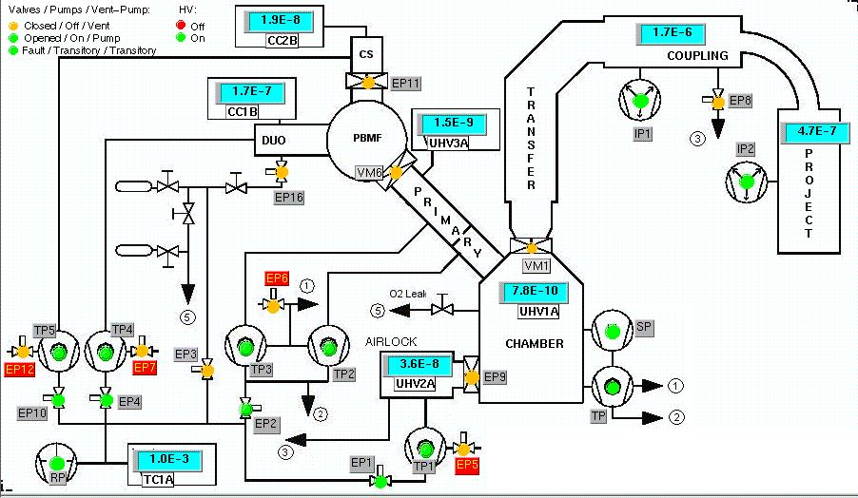

The different components are identified hereunder :

IMS 7f Pumps:
Vacuum diagram | Type | Controllers
RP | Alcatel 2015A rotary pump (15 m3/h) or dry pump triscroll (Varian) | -
TP0-TP1-TP2-TP3 | Varian V301 Navigator turbo pump (250 l/s) | Varian
TP4-TP5 | Varian Macrotorr V70 turbomolecular pump (70l/s ) | Varian
TSP | Titanium Sublimator | Varian
IP2 | Varian ion pump (150 L/ sec) (or equivalent) | Varian
IP1-IP3-IP4 | Varian ion pump (75 L/ sec) (or equivalent) | Varian
Contents

IMS 7f Vacuum gauges:
Vacuum diagram | Type | Multigauge  Controller (Varian)
TC1A | Varian 531 thermocouple type | A
CC1B  CC2B | Varian 525 cold cathode gauge type  Varian 525 cold cathode gauge type | B  B
UHV1A | Varian UHV24 High vacuum gauges (10-11 Torr range) (or equivalent) | A
UHV2A | Varian UHV24 High vacuum gauges (10-11 Torr range) (or equivalent) | A
UHV3A | Varian UHV24 High vacuum gauges (10-11 Torr range) (or equivalent) | A
Contents

IMS 7f Valves:
Vacuum diagram | Type
VM1 | Sample chamber/Transfer optics, manual isolation valve with status indication
VM2 | Duoplasmatron manual gas introduction valve (VAT 59024-KE01 or Leybold 28341)
VM3 – VM4 | Gas bottles regulator (Air Liquid DLRS-N5 or Matheson 3102-580/540 in 0.5)
VM5 | Manual isolation gas valve (Oxygen /Argon usage)
VM6 | Manual valve for isolation of the sources from the primary optics
VM7 - VM8 | Manual gas pressure regulators for F.A.B.I.M. and oxygen floading applications
VM9 | Manual isolation valve for the Gallium source
from EP1 to EP7 & EP10, EP12 | Pneumatic valve (VAT serie 26-DN16) without position indicator (or equivalent)
EP8 | Pneumatic valve ( VAT serie 26-UHV-DN25 ) (or equivalent)
EP9 | Pneumatic gate valve (VAT serie 01-DN40) with position indicator (or equivalent)
EP11 | Pneumatic gate valve (VAT serie 08-DN50) with position indicator (or equivalent)
VM10 | Airlock door

Additional valves for fast airlock
Vacuum diagram | Type
EP13, EP15 | Pneumatic valve (VAT serie 26-DN16) without position indicator (or equivalent)
EP14 | Pneumatic gate valve (VAT serie 08-DN50) with position indicator (or equivalent)

Contents

IMS 7f Automated Vacuum Control Chassis :
The IMS 7f vacuum system automation is handled by a dedicated processor located in the Vacuum control chassis (0045637870)

FRONT PANEL :  There is no manual command on this chassis and thus the front panel is a blind one. | REAR PANEL:
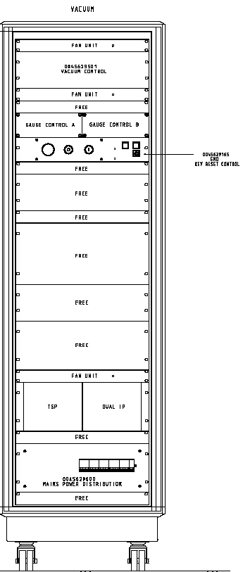 | 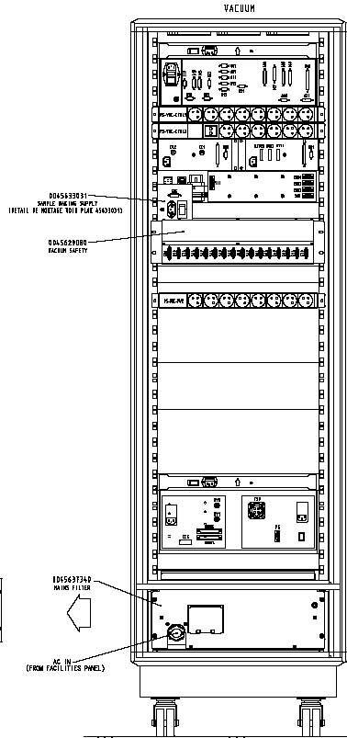
Contents

REAR PANEL:

POWER SWITCH Delivers the 220 VAC to the entire Automated Vacuum Control chassis.
FUSES 1-2-3 Protection for each section of the electronics included in the chassis (1A).

CABLES/PLUGS

J600 JRS Connection type RS232 for communication with the control units of the gauges (start-up / survey/ turn-off) and ion pump controller.
J605 PT0 Connection to the sample chamber turbopump (TP0) controller.
J607 PT1 Connection to the airlock turbopump (TP1) controller.
J609 PT2 Connection to the primary column turbopump (TP2) controller.
J611 PT3 Connection to the primary column turbopump (TP3) controller.
J613 PT4 Connection to the Duoplasmatron (TP4) controller.
J615 PT5 Connection to the Cesium source turbopump (TP5) controller.
J617 BAKING Connection to the bake-out of the instrument through the Power distribution chassis.
J618 PT6 Not connected
J622 TSP Connection to the Titanium sublimation power supply
J624 Secu HV Connection to the security box 45629080
J627 Airlock Connection to Airlock box.
J630 KEY Main ON-OFF key control for the energizing of the electronic system.
J631 HOST Connection type RS232 for communication with the HOST computer.
J633 EVA Connected to the electro-pneumatic relays distribution panel for reading the status of the main pneumatic gate valves (CLOSED/OPEN).
J648 PVA Connected to the electro-pneumatic relays distribution panel for control of the pneumatic valves .
J649 not Connected
J821 WATER Connection to the security box for water security.
J822 Supply Power supply of the security box
JUMPER « RE-START » Allows automation to restart the pumping operation of the instrument after a power black-out.
JUMPERS « GA/Cs/DUO ». Indicates the availability of the corresponding source to the automation when connected.

Rear panel with connections is shown in the next figure

Contents

Vacuum automat rear panel
Contents

IMS 7f Gauge control chassis and pump supplies :

TURBOPUMPS CONTROLLERS CHASSIS
The six turbopumps of the physical instruments are driven by 7 Varian controllers .

VACUUM GAUGES CONTROLLERS CHASSIS
All the vacuum gauges of the instrument are controlled by 2 multigauge Varian controllers . The Automated Vacuum Control chassis is in permanent communication with the multigauges controllers through the RS 232 type network, for energizing, pressure reading and turn off.

n Vacuum pressures must be measured in mbar (set-up of the controllers) for correspondence with the program included in the automation system.
n For communication with the control units of the gauges, the speed of the transmission of the data through the RS 232 network is 9600 bauds. (No parity)

? Note: The user may control manually the gauges by a direct action on the multigauges controller, on the front panel.

SPECTROMETER ION PUMPS POWER SUPPLY CHASSIS
The two pumps of the spectrometer IP1 and IP2 are controlled from 1 chassis dualPI .
The Automated Vacuum Control Chassis is in permanent communication with the Multivac chassis through an RS232 type serial line for startong and stopping the pumps and for pressure reading.

n For communication with the Multivac ion pump, the speed of the transmission of the data through the RS 232 network is 4800 bauds. (No parity)

TITANIUM SUBLIMATION CONTROL UNIT
This unit controls and supplies the Titanium Sublimation filaments TSP located on top of the sample chamber turbo pump.
The Automated Vacuum Control Chassis gives the sublimation autorisation by closing a relay of the interlock command (P5) of the TSP controller.
Contents

The IMS 7f BAKING SYSTEM :

IMS 7f BAKE-OUT SYSTEM DESCRIPTION
The IMS 7f baking system includes the following heating components :

Description location Power

q POWER DISTRIBUTION Box #1: Primary Column/ Sample Chamber (front)
n Heating collar 60 W Primary Column Turbopump 2
n Heating collar 60 W Primary Column Turbopump 3
n Heating collar 100 W Airlock Turbopump 1
n Heating ribbon 500 W Airlock and Sample chamber
n Heating Collar 200W Sample Chamber
n Heating ribbon 500 W Primary Column

Total 1420 W

q POWER DISTRIBUTION Box #2: (Sample chamber(rear)/Spectrometer )
n Heating ribbon Spectrometer - Transfer column 500 W
n Heating ribbon Projection - Detection column 500 W
n Heating resistances Spectrometer Ion Pump IP1 200 W
n Heating resistances Projection Ion Pump IP2 200 W
n 4 Heating resistances Rear part of Sample chamber 300 W
( 2x50 + 2x100 )
Total : 1700 W

Contents

GENERAL OPERATION
q The activation of the baking system is combined with the total shut-down of the Electronics chassis. The remaining units are still powered during the bake-out:
n Computer system and accessories
n Vacuum automation system (pump, electrovalves, gauges)
n Air compressor.

q To minimize the heat dispersion from the body of the instrument in the laboratory, the coverage with large aluminum foil is recommended.

q During the bake-out, the ion pump intensities absorbed (consumption) are taken in account by the Automated vacuum system. A normal raise of three orders of magnitude is to be expected on the ion pumps vacuum pressures. This process is generally slow.

q The vacuum automation may interfere with the bake-out: an interruption of the bake-out may be decided due to a sudden degradation or a steady vacuum indication. The vacuum gauges will then be dis-energized and the pumping process will be stopped in the supposed defective section. An error message will be displayed (fault).
Contents

SETTING TO WORK
Preparation for bake-out:
- No routine other than baking is activated.
- compressed air pressure > 4 bars
- All electronics chassis (to the exception of the units displayed in § IMS 7f Automated Vacuum Control Chassis .) must be turned OFF. When the bake out process will be over, it will be recommended to power ON the chassis one by one avoid a huge intensity peak when the electronic key will be re-energized.
- The insulation valves are opened
- The instrument is entirely under vacuum.

Run the function Start from the vacuum synoptics after having setting the baking duration (6 to 72 hours)
n If the chamber alnalysis vacuum gauge UHV1A < 10⁻⁵ mbar and airlock vacuum gauge UHV2A < 10⁻⁵ mbar and primary column vacuum gauge UHV3A < 10⁻⁵ mbar :
Power distribution WR1
n If spectro and projection ion pump vacuum < 10⁻⁵ Torr :
Power distribution WR2

Contents

SOFTWARE OPERATION – SYNOPTIC IN ‘CONTROL AUTO’ MODE:

The IMS 7f vacuum system is normally operated from the Vacuum synoptic window. This is accessed from the « Vacuum » icon of the IMS 7f Board. Standard vacuum procedures are operated from the automatic mode (CONTROLS AUTO) of the synoptic. Elementary functions can be accessed from the Manual mode (CONTROLS MANUAL) of the synoptic.
We describe fisrt the ‘CONTROLS AUTO’ mode, which is the only one currently accessiible to the operator. The ‘CONTROLS MANUAL’ mode is described in the next section.

Vacuum synoptic window (CONTROLS AUTO mode)
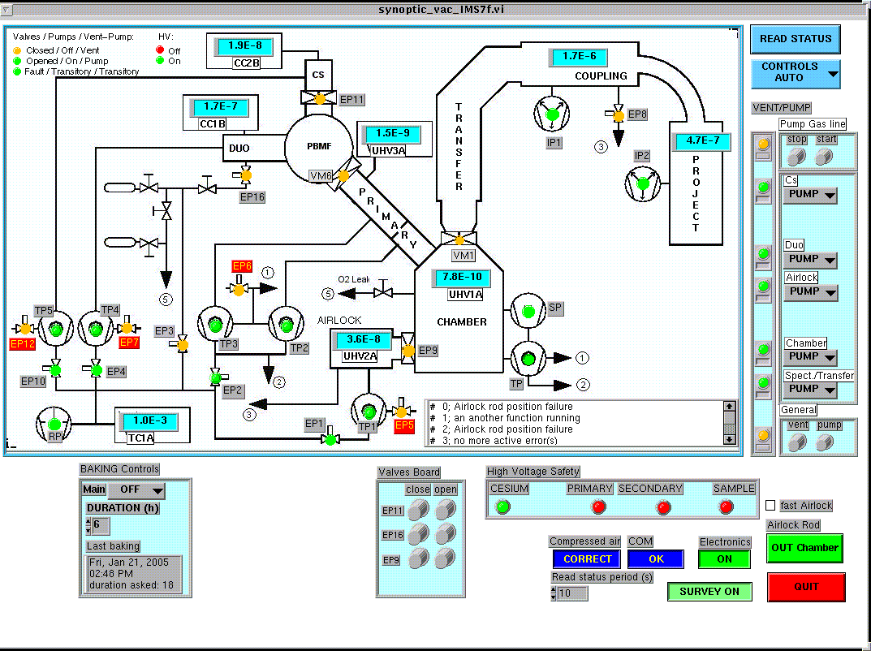

Hereunder, some general considerations on the vacuum operation and the decription of the different vacuum procedures.
Contents

VACUUM OPERATIONS :
To the exception of the airlock pump-down/ventilation procedures (5s) and Cesium, DUO-Primary Column (30s), all other operations are activated after a delay of 30 sec to 1 minute following the engagement of a PUMP or VENT order. Thus, the user benefits of such delay to correct a mis-operation and change procedure by selecting the complementary key (VENT or PUMP). During the original “1 minute” delay, the vacuum system comes back to its original procedure.
Only one vacuum operation at a time is validated by the automation.
Contents

INTERRUPTION OF A VACUUM OPERATION, ERROR MESSAGES:
Any vacuum procedure interruption order is taken in account anytime during a process, but the effective change is applied when the automation will allow it during the process.
Prior to start any vacuum procedure, the automation verifies the compressed air pressure for further activation of the pneumatic valves ( 4 bars ⎯ 72 PSI minimum).
A recommended relative Nitrogen gas pressure for ventilation of any section of the instrument is 0.5 bar ⎯ 3.75 PSI.
During the process of a vacuum operation engaged, the automation permanently verifies the necessary conditions to be respected in order to complete this process. If one of these conditions is not respected, the automation interrupts the process, displays an error message on the Host Vacuum terminal and try to go back to the previous operation of the vacuum system.
To access to the error messages delivered by the Host computer, refer to the corresponding chapter.
In some cases, after an interruption, the return to the previous vacuum operation cannot be achieved. The error message will be displayed and the process is on hold until the user corrects the procedure.
Contents

VACUUM SURVEY SYSTEM:
The Vacuum Survey System is always activated in AUTO MODE. This system verifies permanently the operation of the pumps and the gauges. If no error is noticed in the operation of the vacuum system and if the level of vacuum is considered sufficient, the Vacuum Survey System allows the operation of the high voltages. The different conditions (valves state and/or pressure thresholds) for allowing the high voltages in the different sections are given hereunder :
n The primary high voltages may be powered if:
- The manual Primary column (VM6) isolation valve is open
- The primary column pressure ( UHV3A) < 10⁻⁵ Torr
- The Duo chamber pressure (UHV1B) < 5.10⁻⁴ Torr

n The secondary high voltages are validated if:
  - The manual isolation valve Main chamber/Spectrometer (VM1) is open
  - The Sample chamber pressure ( UHV1A ) is < 5.10⁻⁵ Torr
  - Transfer ionic pump vacuum < 1.10⁻⁶ Torr

n The sample high voltage is allowed if:
- The isolation valve Sample chamber/Airlock (EP9) is closed
- The secondary high voltages are activated.

n The Cesium high voltage is allowed if:
- The primary column pressure (UHV3B) < 5.10⁻⁴ Torr
- Water present.

All the pressure reading from the vacuum gauges and any pumps and valves ( with position indicator ) are alternatively monitored by the automation. If a defect is monitored on any of the gauges, valves or pumps, an Error message will be displayed in the Vacuum synoptic window of the Sun. Survey reading period is of the order of 60 to 100 ms.
Contents

POWER FAILURE:
After a power failure, if the 220 VAC is restored in the laboratory and the restart-switch is in ‘Y’ position, the automation will try to restore the vacuum status which was activated prior to the power black-out.
During this process, the Vacuum Automat will be in the Busy state, any Pumping or Venting operations requested by the user will be automatically disactivated.
If the automation is not able to complete this pumping operation in a particular section of the instrument, the status of this section will be kept in the initial state but all the components of this section (pumps, gauges, valves) will be stopped or closed.

PUMP OR VENT OPERATION:
During a vacuum operation, an error message will be sent to the computer Vacuum Synoptic window:
- If a serious defect is detected, the function ordered will be aborted and the system should come back to its original status.
- If a new procedure is started before the previous one is completed.
Contents

VACUUM PROCEDURES :

Pump/Vent Cesium source

Preliminary conditions:1. No other procedure is active.
2. The Cesium source isolation valve EP21 is closed.
3. Compressed air pressure is > 4 bars.

q Pumping the Cs gun chamber:
F Select the Cesium “PUMP” key on the Vacuum Synoptic.
n After 30 seconds and if EP11 is confirmed as CLOSED, primary valves (EP1, EP2, EP3 & EP4) will be closed.
n EP10 opens and TP5 is started, allowing the pumping of the Cesium Source by the rotary pump RP and the turbopump TP5.
n When the TC1A thermocouple vacuum measurement reaches 10-1 Torr ( 5 mn max), EP1, EP2, EP3 & EP4 are then set to their previous status.
n When the turbopump TP5 reaches full rotational speed ( 20 mn max ), the Cesium source gauge CC2B is energized automatically. Vacuum indication will be displayed by the corresponding Varian controller, the pressure will then be monitored permanently by the Automation (Vacuum Survey System).

q Venting the Cs gun:
F Select the Cesium “VENT” key on the Vacuum Synoptic.
n After 30 seconds, if EP11 is confirmed as CLOSED, Cesium HV is disabled (if not previously turned OFF by the operator ).
n Cs primary pump valve EP10 closes, Cesium turbo pump TP5 and Cs Gauge CC2B are stopped.
n After 10 seconds, EP12 is opened, allowing the Nitrogen gas to flow into the Cs gun.
n After 40 seconds, EP12 closes. Cs gun VENT is completed.
Contents

Pump/Vent Duoplamatron
Preliminary conditions:
- No other procedure is active.
- Compressed air pressure is > 4 bars.
- The Cesium source valve EP11 is closed.
- The primary column/Duoplasmatron isolation valve VM6 is closed.

q Pumping the Duoplasmatron chamber:
F Select the Duo “PUMP” key on the Vacuum Synoptic.
n After 30 seconds and if EP11 and VM6 are confirmed as CLOSED, primary valves (EP1, EP2, EP3 & EP4) will be closed.
n EP4 is opened and TP4 is started,
n When the TC1A thermocouple vacuum measurement reaches 10-1 Torr ( 3 mn max), EP1, EP2, EP3 & EP4 are then set to their previous status.
n When the Duo turbopump TP4 reaches full rotational speed ( 20 mn max ), the Duo gauge CC1B is started.

q Venting the Duoplamatron chamber:
F Select the Duo “VENT” key on the Vacuum Synoptic.
n After 30 seconds, if EP11 and VM6 are confirmed as CLOSED, Cesium HV is disabled (if not previously turned OFF by the operator ).
n EP4 valve is closed, Duo turbopump TP4 is stopped, and Duo Gauge CC1B is stopped.
n After 10 seconds, primary column vent valve EP7 is opened, allowing the Nitrogen gas to flow into the Cs gun.
n After 40 seconds, EP7 is closed. Duoplasmatron chamber VENT is completed.

WARNING: If the ARC high voltage is present on the Duoplasmatron when the foreline is pumped down between 1 to 10-3 mbar, H.V. discharge will occur inside the glass pipe insulator. This will lead to excessive current drawn on the H.V. power supply, and may cause damage to the electronics.

WARNING: Never forget to reintroduce the gas of your choice to the line (pressure = 0.3 bar - 4 PSI) otherwise damage to the instrument is to be expected. (Refer to the previous « WARNING »)

Contents

Pump/Vent Airlock:
Preliminary conditions:
- No other procedure is active.
- Compressed air pressure is > 4 bars.
- The airlock/sample chamber isolation valve EP9 is closed.

q Pumping the Airlock:
F⎯ Select the Airlock “PUMP” key on the Vacuum synoptic (figure 3).
n After 5 seconds, if EP9 is confirmed as CLOSED, primary valves EP2, EP4 and EP14 (fast airlock option) will be closed.
n EP1 opens, TP1 is started, allowing the pumping of the Airlock.
n When the TC1A thermocouple vacuum measurement reaches 10-1 mbar ( 10 mn max), EP2, EP4 and EP14 (fast airlock option) are then set to their previous status.
n When the turbopump TP1 reaches full rotational speed ( 40 mn max ), the airlock gauge UHV2A is energized automatically. Vacuum indication will be displayed by the corresponding Varian controller, the pressure will then be monitored permanently by the Automation (Vacuum Survey System).

q Venting the Airlock:
F Select the Airlock “VENT” key on the Vacuum synoptic.
n After 5 seconds, if EP9 is confirmed as CLOSED, EP1 is closed, TP1 and UHV2A are stopped.
n After 4 seconds, vent airlock valve EP5 is opened, allowing the Nitrogen gas to flow into the Airlock.
n After 3 minutes, EP5 closes. The ventilation of the Airlock is completed.
Contents

Pump/Vent Analysis Chamber and Primary column
Preliminary conditions:
- No other procedure is active.
- Compressed air pressure is > 4 bars.
- The airlock/sample chamber isolation valve EP9 is closed.
- The Source valve VM6 is closed.
- Spectro/analysis chamber isolation valve VM1 is closed

q Pumping the analysis chamber and the Primary column
F⎯ Select the Chamber “PUMP” key on the Vacuum synoptic.
n After 60 seconds, if VM1, EP9 and VM6 are confirmed as CLOSED, primary valves EP1, EP4 and EP10 will be closed.
n Primary vacuum valve EP2 is opened, primary column and chamber turbopumps (TP0, TP2, TP3) are started.
n When the TC1A thermocouple vacuum measurement reaches 10-1 Torr ( 6 mn max), EP1, EP4 and EP10 are then set to their previous status.
n When the turbopumps TP0, TP2 and TP3 reach full rotational speed ( 20 mn max ), both the sample chamber gauge UHV1A and the primary column UHV3A are energized automatically. Vacuum indication will be displayed by the corresponding Varian controller, the pressure will then be monitored permanently by the Automation (Vacuum Survey System).
n Operation of the Titanium Sublimation Pump (under the control of the Vacumm Survey System) is allowed.

q Venting the analysis chamber and the Primary column
F⎯ Select the Chamber “VENT” key on the Vacuum synoptic .
- After 60 seconds, if VM1, EP9 and VM6 are confirmed as CLOSED, Primary column HV, secondary HV and Sample HV are unabled
- EP2 is closed, turbopumps TP0, TP2 and TP3 are stopped. Both gauges UHV1A and UHV3A are set off.
- After 10 seconds, vent valve EP6 is opened during 6 mn, allowing the Nitrogen gas to flow into the Sample chamber.
Contents

Pump/Vent Spectrometer
Preliminary conditions:
- No other procedure is active.
- Compressed air pressure is > 4 bars.
- Isolation valve EP9 is closed
- Isolation valve VM1 is closed.

q Pumping the spectrometer
Necessary conditions: Airlock must be vented
F Select the Spect/Transfer “PUMP” key on the Vacuum synoptic .

- After 60 seconds, if VM1 and EP9 are confirmed as CLOSED, the primary valves EP2, EP4 and EP10 will be closed.
- Valves EP1and EP8 are opened and the airlock turbopump TP1 is started.
- When the TC1A vacuum indication reaches 10-1 Torr (9 mn max), primary valves EP2, EP4 & EP10 return in the previous state.
- When turbopump TP1 reaches full speed ( 20 mn max ), the airlock gauge UHV2A is energized.
- When the airlock pressure (UHV2A) will reach 5.10-6 mbar (50 mn max), ion pumps IP1 and IP2 are supplied.
- When the ionic pumps IP1 and IP2 vacuum will reach 1.10-5 Torr (120 mn max) EP8 valve is closed.
- The ion pump IP1 supply is switched to the protect mode.

q Venting the spectrometer
Necessary conditions: Airlock must be pumped
F Select the Spect/Transfer “VENT” key on the Vacuum synoptic.
n After 60 seconds, if VM1 and EP9 are confirmed as CLOSED, HVs (primary, secondary and sample) are turned OFF for security purposes.
n EP1 is closed, TP1 and gauge UHV2A energizing are stoppped.
n After 10 seconds, valve EP8 is opened. Then EP5 is opened, allowing the Nitrogen gas to flow into the Airlock and the Transfer line.
n After 8 minutes, EP5 closes. The Transfer line ventilation is completed.
Contents

Pump/Vent "General"
Preliminary conditions:
- No other procedure is active.
- Compressed air pressure is > 4 bars.
- Airlock/analysis isolation valve EP9 is closed
- Cs source isolation valve EP11 is closed
- Duo/Primary isolation valve VM6 is closed
- Isolation valve VM1 is closed.
- All the different sections of the instrument are in the same status.

q General Pumping
F Select the General “PUMP” button on the Vacuum synoptic.
"General pumping" consists of achieving simultaneously all the pumping routines,

q General Venting
F Select the General “VENT” button on the Vacuum synoptic.
"General venting" consists of achieving simultaneously all the venting routines,
Contents

Pump Gas line
Preliminary conditions:
  - No other procedure is active.
  - Compressed air pressure is > 4 bars.

F Select the Gas “PUMP” key on the Vacuum synoptic .
- After 30 seconds delay, The primary column HV is disabled
- All the primary vacuum valves are closed
- The Gas line primary vacuum valve EP3 is opened
- When the TC1A vacuum indication reaches 5 10-3 Torr (3 mn max), primary vacuum valves return in the previous state.
Contents

Open/Close of Isolation valves:
      - Cesium Chamber isolation valve EP11
Preliminary conditions:
- No other procedure is active.
- Compressed air pressure is > 4 bars.
- Cesium and Duoplasmatron are in the same status, vented or pumped.
F Select the EP11 “Open” key on the Vacuum synoptic .
- If both the Cs and the Duo chamber are vented and all the pumping devices are stopped, The valve is opened
- If the Cs chamber CC2B < 10-4 Torr and Duo chamber CC1B < 10-4 Torr, if the turbopumps TP4 and TP5 are at full speed, if the gas line valve EP16 is closed, if the airlock box switch is turned "Open", the Cs chamber EP11 is opened

F Select the EP11 “Close” key on the Vacuum synoptic .
- EP11 is closed

      - Analysis Chamber/ Airlock isolation valve EP9
Preliminary conditions:
  - No other procedure is active.
  - Compressed air pressure is > 4 bars.
  - Both Analysis chamber and Airlock have the same status (pumped or vent)
  - loading rod is in Home position.
F Select the EP9 “Open” key on the Vacuum synoptic .
- If both the analysis chamber and the airlock are vent and all the pumping devices are stopped, the valve EP9 is opened.
- If the analysis chamber gauge UHV1A < 5. 10-5 Torr and the airlock gauge UHV2A< 5. 10-5 Torr and if the turbopumps TP0 and TP1 are at full speed, the valve EP9 is opened.
F Select the EP9 “Close” key on the Vacuum synoptic .
- If the loding rod is in Home position, the valve EP9 is closed. (5mn max)
Contents

CONTROL DISPLAY :

In addition to the previous commands, the Vacuum synoptic also displays some vacuum relevant informations, mostly located in the lower right corner of the synoptic.

High Voltage Safety :
This indicates if the different High Voltages (Cesium, Primary, Secondary, Sample) are authorised by the vacuum status.
If high voltage is (is not) authorised, the ‘software LED’ is green (red).

Compressed air :
Indicates if the air pressure is CORRECT (> 5 bars) or not (FAULT).

Communication status :
Indicates if the communication status COM is correct (OK) or not (FAULT).

Electronics status :
Indicates if the Electronics is ON or OFF.

Survey status :
Indicates if the vacuum survey function is activated (SURVEY ON in green field) or not (SURVEY OFF in red field).

OTHER FUNCTIONS :
A few commands not relevant from the other types are described hereunder.

Connect :
This command is used to refresh the communication line with the Z chassis, in case of a failure with the chassis ON.

Read status period :
Define the period ( in seconds) for refreshing the vacuum synoptic. The minimum value is 10 seconds.

Read status :
This command permit to refresh manually at any time the vacuum synoptic

Quit :
This command is used to quit the Vacuum synoptic.
Contents

SOFTWARE OPERATION – SYNOPTIC IN ‘CONTROLS MANUAL’ MODE:
Warning : This mode is an expert mode reserved for non standard operation. As any components can be activated without securities, it must be used with the greatest care.

The ‘CONTROLS MANUAL’ mode of the synoptic is accessed from the standard ‘CONTROLS AUTO’ mode. For this click on the CONTROLS AUTO key of the vacuum synoptic. This opens the Authorisation window in which the expert user enter its password and click on the ‘Continue’ key to confirm.
This opens the ‘CONTROLS MANUAL’ mode of the synoptic
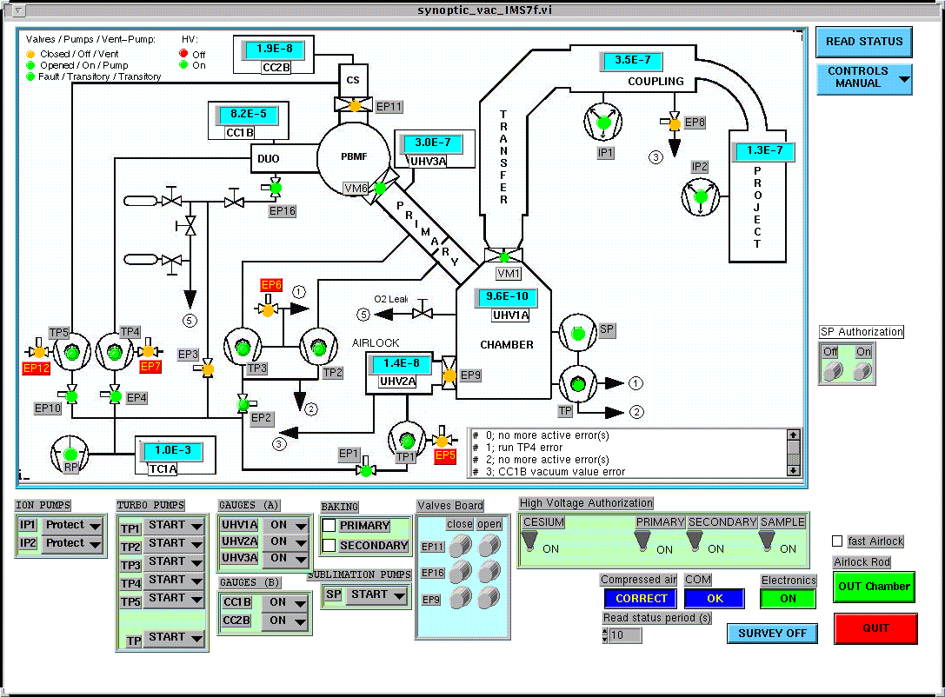
In this mode, all the individual components related to the vacuum system can be controlled directly. We distinguish four main types which we describe successively :
- the pump commands
- the gauge commands
- the valve commands
- the other commands
Contents

Pump commands :

Turbo pumps (TP0 to TP6):

F To start the pump (which is in the STOP state), select ‘START’ on the corresponding Turbo pump key .
F To stop the pump (which is in the START state), select ‘STOP’ on the corresponding Turbo pump key .

Ion pumps (IP1 and IP4):

F To start the pumps (which is in the STOP state), select ‘START’ on the Ion pump key
F To stop the pumps, select ‘STOP’ on the corresponding Ion pump key .
F To set the pumps in Protect state, select ‘Protect’ on the corresponding Ion pump key . The protect mode is a security mode in which the pump current is limited. In case of pressure increase, the pump is thus automatically switched Off. This is the standard operating mode of the ion pumps.

Gauges commands (UHV1A-3A, UHV1B, UHV1C-3C, CC1B-2B):

F To start a gauge (which is in the STOP state), select ‘START’ on the corresponding GAUGES key .
F To stop a gauge (which is in the START state), select ‘STOP’ on the corresponding GAUGES key .
Contents

Valve commands :
Warning : be extremily cautious when operating the valves in this mode. In case of misuse, you can damage the machine (especially when opening a vent valve).

Simple valves (EP1 to EP23):

F To open a valve (which is in the close state indicated by orange ‘soft LED’), go with the mouse on that valve and click with the left button of the mouse. The soft LED then turns to green color when the valve is open.

F To close a valve (which is in the open state indicated by green ‘soft LED’), go with the mouse on that valve and click with the left button of the mouse. The soft LED then turns to orange color when the valve is closed.

Valves with position indicator (EP9, EP11, EP21, EP22 ):

These valves are commanded from the Valves board on the vacuum synoptic (figure 5).

F To open a valve (which is in the close state indicated by orange ‘soft LED’), click with the left button of the mouse on the corresponding ‘Open’ knob of the Valves board on the synoptic.. The soft LED then turns to green color when the valve is open.
F To close a valve (which is in the open state indicated by green ‘soft LED’), click with the left button of the mouse on the corresponding ‘Close’ knob of the Valves board on the synoptic.. The soft LED then turns to orange color when the valve is closed.
Contents

Other commands :

High voltage authorization:
F To give authorization for High Voltage, click on the corresponding ON knob on the vacuum synoptic
F To suppress authorization for High Voltage, click on the corresponding OFF knob on the vacuum synoptic

Connect:
Refer to Connect section

Read status period :
Refer to read status period section

Read status:
Refer to read status section

Quit:
Refer to Quit section

Displays :

Compressed air:
Refer to Compressed air section

Communication:
Refer to Communication section

Electronics:
Refer to Electronics status section

Survey:
Refer to Survey section
Contents

LOCAL MODE :
This mode is activated directly from the 68070 microprocessor board. It is accessed by Program – Vacuum - …. We first describe the programming mode of the menu and then detail the basic functions.
GENERAL MENU
a = “Interactivity” : Access to the « Interactivity menu »
d = “Test vacuum functions” : Access to the « Basic functions »
e = “Test vacuum gauges” : Access to the « Vacuum measurement »

1 : F Type “a” and return pour activer le 'interactivity menu'.
2 : F Type “ ” and return pour activer la fonction désirée.
F Type “0” and return pour retourner au 'general menu'.

INTERACTIVITY MENU

a: chge_stat_duo --> PUMP | Status Pump of the duoplasmatron
b: chge_stat_duo --> VENT | Status Vent of the duoplasmatron
c: print_on | Displays every dialogue 68070/user
d: print_off | Desactivation of previous displays
e: print status | Pump or Vent status reading
f: chge_stat_transfert--> PUMP | Status Pump of the transfert
g: chge_stat_transfert--> VENT | Status Vent of the transfert
i: chge_stat_Cesium--> PUMP | Status Pump of the Caesium
j: chge_stat_Cesium--> VENT | Status Vent of the Caesium
k: chge_stat_chamber --> PUMP | Status Pump of the chamber
l: chge_stat_chamber --> VENT | Status Vent of the chamber
m: print stat selector | keyboard adress table
n: chge_stat airlock--> PUMP | Status Pump of the airlock
o: chge_stat_ airlock--> VENT | Status Vent of the airlock
p: stop_survey | Vacuum survey system desactivation
q: autorisation_survey | Vacuum survey system activation
r: chge_stat_coupling--> PUMP | Status Pump of the coupling
s: chge_stat_ coupling -->VENT | Status Vent of the coupling
t: chge_stat_projection--> PUMP | Status Pump of the projection
u: chge_stat_ projection --> VENT | Status Vent of the projection
v: PROM version | EPROMS Version reading
w: chge_stat_TPairlock --> PUMP | Status Pump of the turbopump airlock
x: chge_stat_ TPairlock --> VENT | Status Vent of the turbopump airlock
0: general menu | Return to general menu

IMS 7f BASIC FUNCTIONS
Marche à suivre pour accéder au fonctions basic:
- : F Type “d”, « return » pour activer le 'vacuum functions'.
- : F Type “x”, « return » pour activer la fonction désirée.
- Pour retourner au 'general menu', type « 222 »

ELECTROVALVES
0 CLOSE_EP1  1 CLOSE_EP2  2 CLOSE_EP3  3 CLOSE_EP4  4 CLOSE_EP5  5 CLOSE_EP6  6 CLOSE_EP7  7 CLOSE_EP8  8 CLOSE_EP9  9 CLOSE_EP10  A CLOSE_EP11 | B CLOSE_EP12  C  D CLOSE_EP14  E CLOSE_EP15  F CLOSE_EP16  10 OPEN_EP1  11 OPEN_EP2  12 OPEN_EP3  13 OPEN_EP4  14 OPEN_EP5  15 OPEN_EP6 | 16 OPEN_EP7  17 OPEN_EP8  18 OPEN_EP9  19 OPEN_EP10  1A OPEN_EP11  1B OPEN_EP12  1C  1D OPEN_EP14  1E OPEN_EP15  1F OPEN_EP16
HIGH VOLTAGES
20 AUTO_HV_PRIM  21 AUTO_HV_SEC  22 AUTO_HV_CS | 24 AUTO_HV_ECH  25 STOP_HV_PRIM  26 STOP_HV_SEC | 27 STOP_HV_CS  29 STOP_HV_ECH
ELECTROVALVES
2A CLOSE_EP17  2B CLOSE_EP18  2C CLOSE_EP19  2D CLOSE_EP20  2E CLOSE_EP21  2F CLOSE_EP22 | 30 CLOSE_EP23  31 CLOSE_EP24  32 OPEN_EP17  33 OPEN_EP18  34 OPEN_EP19  35 OPEN_EP20 | 36 OPEN_EP21  37 OPEN_EP22  38 OPEN_EP23  39 OPEN_EP24
CDE
3A START_SURVEY | 3B | 3C STOP_SURVEY
PUMPS
3D STOP_PT1  3E STOP_PT2  3F STOP_PT3  40 STOP_PT4  41 STOP_PT5  42  43  44 STOP_IP1 | 45 STOP_IP2  46 STOP_SUB_CHAMB  47 STOP_PT0  48 RUN_PT1  49 RUN_PT2  4A RUN_PT3  4B RUN_PT4  4C RUN_PT5 | 4D  4E  4F RUN_IP1  50 RUN_IP2  51 RUN_SUB_CHAMB  52 RUN_PT0  53 PROTECT_IP2  6B PROTECT_IP1
STATUS DISPLAY
54 STATUS_VM1  55 STATUS_VM6  56 STATUS_EP14  57 STATUS_EP9 | 58 STATUS_EP11  59 STATUS_VM9  5A STATUS_PT1  5B STATUS_PT2 | 5C STATUS_PT3  5D STATUS_PT4  5E STATUS_PT5  5F STATUS_PT0  60 STATUS_ELECT
BAKING
61 DISABLE ELECT  62 RUN_ETUV_PRIM  63 RUN_ETUV_SEC | 64  65 ENABLE ELECT  66 STOP_ETUV_PRIM | 67 STOP_ETUV_SEC  68
GAUGES
6C RUN_CC1B  6D STOP_CC1B  6E RUN_CC2B  6F STOP_CC2B | 70 RUN_UHV1A  71 STOP_UHV1A  72 RUN_UHV2A  73 STOP_UHV2A | 74 RUN_UHV3A  75 STOP_UHV3A  76 RUN_UHV1B  77 STOP_UHV1B

IMS 7f VACUUM GAUGES LABEL
GAUGES |  | LOCATION
TC1A | MODULE A | ROTARY PUMP LINE
UHV1A |  | ANALYSIS CHAMBER
UHV2A |  | AIRLOCK
UHV3A |  | PRIMAIRY COLUMN
CC1B | MODULE B | DUOPLASMATRON
CC2B |  | CAESIUM SOURCE

STATUS

Device | Closed | Medium | Open
VM1 | = 1 | 3 | = 2
VM6 | = 4 | 12 | = 8
EP14 | = 16 | 48 | = 32
EP9 | = 64 | 192 | = 128
EP11 | = 256 | 768 | = 512

Device | Full speed | Stop/accelération
TP0 | 0 | 2
TP1 | 0 | 4
TP2 | 0 | 8
TP3 | 0 | 16
TP4 | 0 | 32
TP5 | 0 | 64
TP6 | 0 | 128

Electronic | 0 | OFF
Electronic | 32768 | ON

From the main menu, go to the Interactivity (type A).
Select Print_stat_sélector (type M).
Result will be displayed as 1111 1110 1101 1111, from bit#15 to bit#0.

bit5 à 0 = correct air pressure
bit9 à 0 = loading rod out of the chamber (closing EP9 enabled).

VACUUM MEASUREMENT

1 : F Type “e” and « return » for activating the 'vacuum gauges'.test
2 : F Type “x” and « return » for activating the required function.

F Back to the main menu: type « 222. »
Function | Address | Pressure value  ( Torr )
TC1A | 0 | 1.33.10⁻³
UHV1A | 1 | 4.10⁻⁹
UHV2A | 2 | 9.36.10⁻⁷
UHV3A | 3 | 4.10⁻⁷
CC1B | 4 | 1.8.10⁻⁶
CC2B | 5 | 5.7.10⁻⁶
I P1 vacuum | 6 | 7.26.10⁻⁸
I P2 vacuum | 7 | 7.26.10⁻⁸

